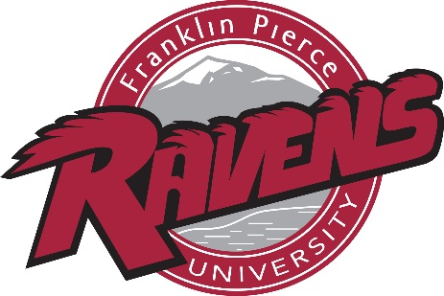

2017-18 Franklin Pierce University Men’s Golf Roster

Name Yr. Hometown/Previous School
Tom Arisco Sr. Cheshire, Conn./Cheshire
Justin Bennett So. Acushnet, Mass./New Bedford
Liam Donohue So. Vernon, Conn./East Catholic
Keeton Foster So. Spofford, N.H./Keene
Nate Goldsnider Jr. Bolton, Conn./Bolton
Sam Myers So. Colchester, Vt./Rice Memorial
Christopher Pasto Sr. Newton, N.H./Sanborn Regional
Dylan Plis Fr. Camillus, N.Y./West Genesee
A.J. Potvin Sr. Goffstown, N.H./Goffstown
Kurtis Raymond So. Lyndon Center, Vt./Lyndon Institute
Taylor Simpson Sr. Londonderry, N.H./Londonderry
Chris Strange Sr. South Glastonbury, Conn./Glastonbury
Jason Vadnais So. Arundel, Maine/Biddeford
Anthony Vincequere So. Millbury, Mass./Holy Name
Mike Waisnor Jr. Lynnfield, Mass./Lynnfield

Head Coach: Tyler Bishop (fifth season, Franklin Pierce ’08, ‘10)
Assistant Coaches: C.J. Konkowski (third season, University of New Hampshire ‘15), Rick Senatore (first season, Massachusetts ’91)
Team Captain: Tom Arisco
Athletic Trainer: Christine Levreault (12th season, Northeastern ‘02)
Strength & Conditioning Coach: Marcus Williams (second season, Pittsburgh '11)

